- Tên và phân loại:

- Mục đích, ý nghĩa:

- Động lực sử dụng:
- A graphical user interface toolkit,
should let you add properties like
borders or behaviors like scrolling to
any user interface component
- A more flexible approach is to
enclose the component in another
object that adds the border, or
whatever is required
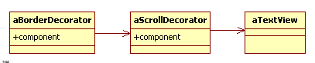
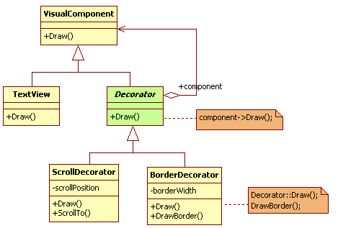
- Khi nào sử dụng:
- To add responsibilities to individual objects dynamically and
transparently, that is, without affecting other objects for
responsibilities that can be withdrawn
- When extension by sub-classing is impractical. Sometimes a
large number of independent extensions are possible and
would produce an explosion of subclasses to support every
combination. Or a class definition may be hidden or otherwise
unavailable for sub-classing
- Cấu trúc
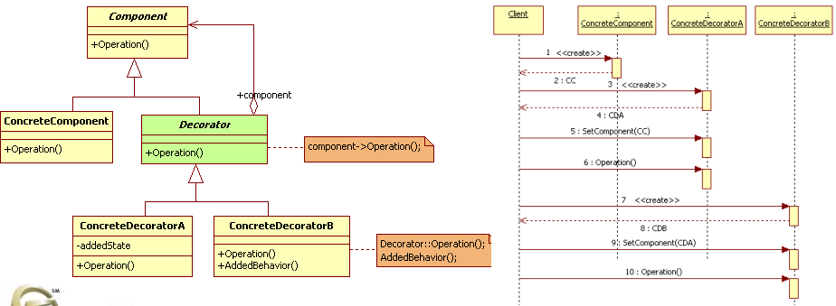
- Các thành viên - Sự cộng tác

- Các hệ quả mang lại:
- More flexibility than static inheritance
• Provides a more flexible way to add responsibilities to objects
than can be had with static (multiple) inheritance. With
decorators responsibilities can be added and removed at runtime simply by attaching and detaching them
- Avoids feature-laden classes high up in the hierarchy
• Offers a pay-as-you-go approach to adding responsibilities.
Instead of trying to support all foreseeable features in a complex,
customizable class, you can define a simple class and add
functionality incrementally with Decorator objects. Functionality
can be composed from simple pieces. As a result, an application
needn't pay for features it doesn't use
- A decorator and its component aren't identical
• Acts as a transparent enclosure. But from an object identity point
of view, a decorated component is not identical to the
component itself. Hence you shouldn't rely on object identity
when you use decorators
- Lots of little objects
• A design that uses Decorator often results in systems composed of
lots of little objects that all look alike. The objects differ only in the
way they are interconnected, not in their class or in the value of
their variables. Although these systems are easy to customize by
those who understand them, they can be hard to learn and
debug
- Chú ý liên quan đến cài đặt:

- Hệ thống thực tế

- Mẫu liên quan
- Adapter: A Decorator is different from an Adapter in that a
decorator only changes an object's responsibilities, not its
interface; an adapter will give an object a completely new
interface
- Composite: A Decorator can be viewed as a degenerate
composite with only one component. However, a decorator
adds additional responsibilities – it isn't intended for object
aggregation
- Strategy: A decorator lets you change the skin of an object; a
strategy lets you change the guts. These are two alternative
ways of changing an object

